How to Document

General Data Protection Regulation – Subject Access Requests (GDPR - SAR)

Author: Ram Niwas Verma

Version: v2.0

Date: 07-Nov-2019

Document ID: GDPRSAR

Table of Contents

1 Document Summary 4

2 Introduction 4

3 Problem Statement 4

4 The Solution 5

5 Scope 5

5.1 In Scope 5

5.2 Out of Scope 5

6 How to Setup 5

6.1 Prerequisites 5

6.2 Setup 6

6.2.1 Import Release 6

• Download “gdprsar.bprelease” file from github location by Ctrl+Click , alternatively open this url: https://github.com/ramniwas2606/Blueprism-GDPR-SAR-Blueprism/ 6

6.2.2 Set Environment Variables 6

7 Instructions 7

8 Executing the Process 8

8.1 Manual Way (On need basis) 8

8.1.1 Go to Studio -> Processes, open “GDPR-SAR Get User Details” process by double clicking on it 8

8.1.2 Double click on Process Information stage available on “Main Page” 8

8.1.3 Check the check box at the bottom left of the “Process Information” screen and click OK 8

8.1.4 Save and close the process 9

8.1.5 Go to Control Room by clicking on Control Tab (Process is visisble after publishing it (Step 8.1.3) 9

8.1.6 Select the process and drag it to the available resource on right hand pan (Resources), a session is created in bottom pan (Environment) with amber colour and status as Pending 9

8.1.7 Select the session (amber coloured) and click on Start Selected Sessions 9

8.1.8 Status will be changed as per Execution Status (Running, Terminated, Stopped, Completed etc.) 9

8.2 Automatic Execution (By scheduler) 10

8.2.1 Go to Control -> Schedules 10

8.2.2 Right click on Schedules and click New Schedule 10

8.2.3 Enter appropriate schedule name and select the frequency, i.e. for daily run, select below (Customize as per business need) 10

8.2.4 Expand Schedule Name and create New Task by right clicking on it if not already created (if already created, just rename it) 10

8.2.5 Follow the instruction as on below screenshot 11

8.2.6 Click on Apply Changes 11

9 Document History 12

# Document Summary

This document provides an overview of GDPR SAR project and explains the steps to handle the SARs of the users using the RPA tool blue prism. This document also explains the instructions on how to install the solution and use it. Instructions for high level debugging is also outlined in this document.

# Introduction

**What is a SAR?**

SAR stand for Subject Access Request. As per regulation in EU law Individuals (usually an employee) have the right to information from their organisation (usually an employer) whether they are processing personal data of an individual or not, if so, it is to be disclosed.

**What is a GDPR?**

The General Data Protection Regulation (EU) 2016/679 (GDPR) is a regulation in EU law on data protection and privacy for all individual citizens of the European Union (EU) and the European Economic Area (EEA). It also addresses the transfer of personal data outside the EU and EEA areas.

Under the GDPR, individuals have the right to obtain confirmation that their data is being processed and access to their personal data. A Subject Access Request (SAR) is the statuary mechanism by which individuals may exercise these rights to access their personal data and verify the lawfulness of the processing.

# Problem Statement

To handle the Subject Access Requests (SARs) effectively within the allowed and legal timeframe is a challenge for most of the employers. The amount of information held about individual (wherever in Organization and in whichever form like personnel file, internal memorandums, meeting notes or simply email correspondence) can be vast. Understanding from the outset how to respond to an SAR is crucial because failing to respond can expose the business to a claim, fines, enforcement action and reputational damage.

# The Solution

**RPA Solution (through Blue Prism tool) for Catering SARs**:

To serve the SARs, a solution/process using RPA tool Blue Prism, is built. The process (so called BOT) accesses a master spreadsheet containing user’s email and/or other details (if provided) which is kept at the location where BOT can access it. Then the BOT iterate through all the rows of spreadsheet one by one, queries database table(s) to fetch the user’s details and share the fetched details with user (requestor) via email. Finally, a report is shared with Controller of the process to inform about the status of the SARs to state if details were found or not with-in organization’s database (this report is optional, which can be switched off by changing an Environment Variable).

# Scope

This section describes the scope of the project at a high level.

## In Scope

The following areas are in scope for this project:

* Individual’s details stored in SQL database tables
* Individual’s details stored in Oracle database to follow shortly

## Out of Scope

The following areas are out of scope for this project:

* Individual’s details stored in other sources than SQL Database like personnel file, internal memorandums, meeting notes or email correspondence

# How to Setup

## Prerequisites

* Blue Prism RPA tool must be pre-installed on the Run Time Resource (where BOT will run)
* Blue Prism tool must be installed and configured on Interactive Client (the machine from where BOT will be managed i.e. scheduling etc.)
* POP3 OR SMTP protocols must be available in order to send emails

## Setup

### Import Release

### Download “gdprsar.bprelease” file from github location by [Ctrl+Click](https://github.com/ramniwas2606/Blueprism-GDPR-SAR-Blueprism/) , alternatively open this url: <https://github.com/ramniwas2606/Blueprism-GDPR-SAR-Blueprism/>

* Import the .bprelease file in Blue prism (File -> Import and browse .bprelease file)

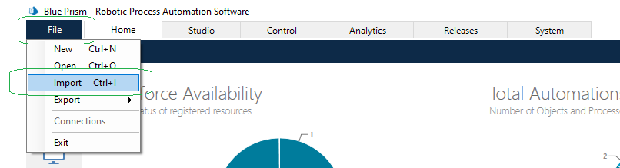

### Set Environment Variables

The value of below Environment Variables (EVs) must be provided/updated as per below table by navigating to System -> Processes -> Environment Variables, in blue prism

|  |  |  |  |  |
| --- | --- | --- | --- | --- |
| Environment Variable  Name | Type of Field | Description | Sample Value (example) | Note |
| GUD_Excel Path | Text - Mandatory | Path of the spreadsheet containing user data for whom SAR is to be catered | C:\GDPRSAR\master.xlsx | Provide the path of the .xlsx file having user details like User Email etc.  **Email column name in the spreadsheet must be kept same, as provided in “GUD_User Email Field in Database Table” environment variable** |
| GUD_Excel Sheet Name | Text - Conditional | Sheet (tab) name with-in the spreadsheet | Data | Mandatory if having more than one sheets with-in spreadsheet  Optional if spreadsheet is having only one sheet within it |
| GUD_Folder Archive Path | Text - Mandatory | Path of the folder where files (like report, .xlsx file etc.) will be archived after processing | C:\GDPRSAR\Archived\ | Place backward slash (\) at the end of the path |
| GUD_From Email Credential Name | Text - Mandatory | Credential Name for the user through which email will be sent | GUD_Email Credentials | Credential with the same name as provided in “Sample Value” and with valid Username/Password must be created under System -> Credentials |
| GUD_Report Flag | Flag - Mandatory | Whether to send report to Controller | True | If set to true BOT will send a report to Controller of the process, if set to False, it will not |
| GUD_Controller Email ID | Text - Mandatory | Email id whom to be contacted in case of any exception/report | [gdpsar-controller@company.com](mailto:gdpsar-controller@company.com) | If more than one email id, enter with comma separated values like [a@abc.com](mailto:a@abc.com), [b@abc.com](mailto:b@abc.com) , |
| GUD_Configure Email SMTP Server | Text - Mandatory | Email Server name, from where email will be sent | server.company.com | POP3/SMTP email server name |
| GUD_Configure Email Server Port | Number - Mandatory | Email Server Port | 10 | Port Number |
| GUD_Configure Email Use SSL Flag | Flag - Mandatory | Use SSL Flag | False | Set it as False |
| GUD_Database Credential Name | Text - Mandatory | Name of the Database Credentials | GUD_Database Credentials | If database is “Windows Authentication”, still create the Credentials with this name and provide blank values in Username and Password in Blue Prism Credentials |
| GUD_Database Server | Text - Mandatory | Database Server where Database resides | databaseserver. amazonaws.com | Database Server where Database resides |
| GUD_Database Name | Text - Mandatory | Name of the database on the server | EmployeeData | Database Name |
| GUD_Database Tables | Text - Mandatory | Comma separated table names, where the data will be fetched from | Employees, Departments, PersonalDetails | Comma separated table names, where the data will be fetched from |
| GUD_Database Table Fields | Text - Mandatory | Comma separated name of the fields **with table name** | Employees.Name, Employees.DOB Departments.Role, PersonalDetails.Email, PersonalDetails.City, PersonalDetails.Address | **Must be in the sequence how table names in “GUD_Database Tables” environment variable**, are mentioned i.e. “Employee” table is appearing first, the field(s) from it must be entered first  Likewise, then from Departments and then PersonalDetails tables |
| GUD_Database Tables Criterias | Text - Mandatory | Comma separated table criteria according to which the data from two tables will be extracted | Employees.ID = PersonalDetails.ID, Departments.ID = PersonalDetails.ID | Must be in sequence how table names in “GUD_Database Tables” environment variable, are mentioned |
| GUD_User Email Field in Database Table | Text - Mandatory | Table Column name in which requestor user's email address is stored in TableName.ColumnName format | PersonalDetails.Email | Table Column name in which requestor user's personal email address is stored, in TableName.ColumnName format |

# Instructions

It is recommended to follow below instructions about the spreadsheet having user emails:

1. Keep the column names of the spreadsheet in format of TableName.FieldName like PersonalDetails.Email
2. More than one column can be entered in the spreadsheet, if needed, like PersonalDetails.Email, PersonalDetails.FirstName etc.
3. Values in environment variables “GUD_Database Table Fields” and “GUD_Database Tables Criterias” must be provided with respective table name i.e. PersonalDetails.Email, PersonalDetails.FirstName
4. Values in environment variables “GUD_Database Table Fields” and “GUD_Database Tables Criterias” must be provided in same sequence of table name how they are provided in “GUD_Database Tables” value
5. All values of folder paths like in "GUD_Excel Path", "GUD_Folder Archive Path" etc. must be ended with a backward slash (“\”) e.g. C:\GDPRSAR\Archived**\**

# Executing the Process

## Manual Way (On need basis)

### Go to Studio -> Processes, open “GDPR-SAR Get User Details” process by double clicking on it

### Double click on Process Information stage available on “Main Page”

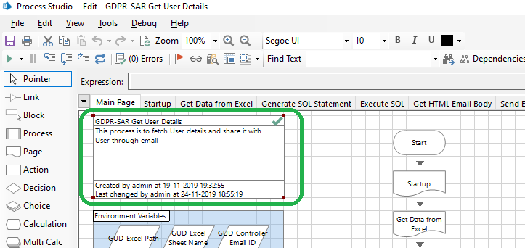

### Check the check box at the bottom left of the “Process Information” screen and click OK

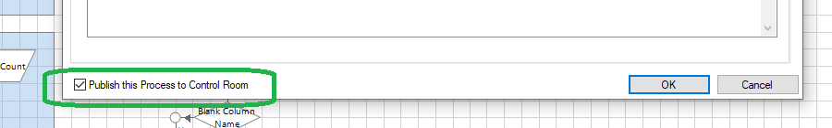

### Save and close the process

### Go to Control Room by clicking on Control Tab (Process is visisble after publishing it (Step 8.1.3)

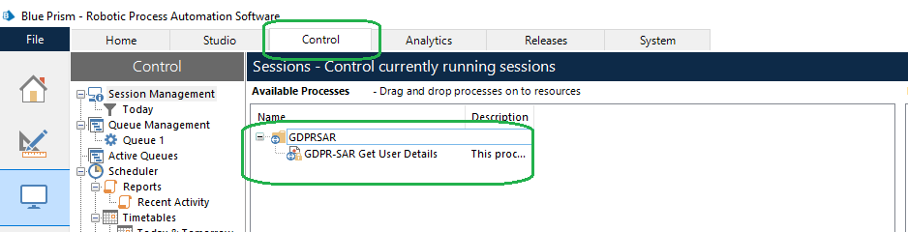

### Select the process and drag it to the available resource on right hand pan (Resources), a session is created in bottom pan (Environment) with amber colour and status as Pending

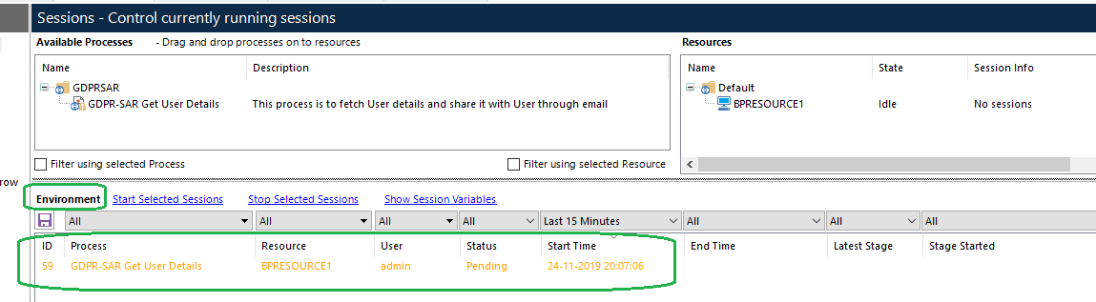

### Select the session (amber coloured) and click on Start Selected Sessions

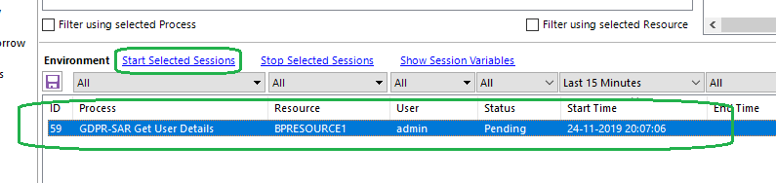

### Status will be changed as per Execution Status (Running, Terminated, Stopped, Completed etc.)

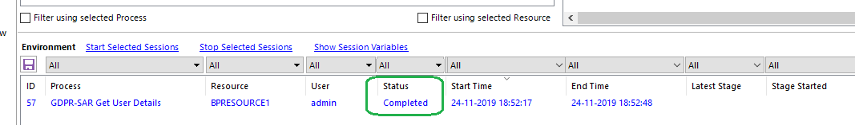

## Automatic Execution (By scheduler)

Create a schedule when the process should be triggered and execute by itself

### Go to Control -> Schedules

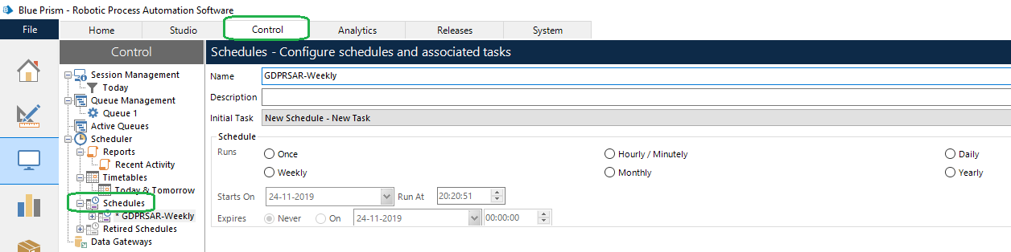

### Right click on Schedules and click New Schedule

### Enter appropriate schedule name and select the frequency, i.e. for daily run, select below (Customize as per business need)

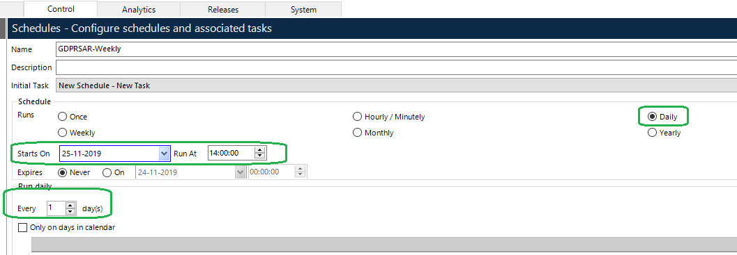

### Expand Schedule Name and create New Task by right clicking on it if not already created (if already created, just rename it)

### Follow the instruction as on below screenshot

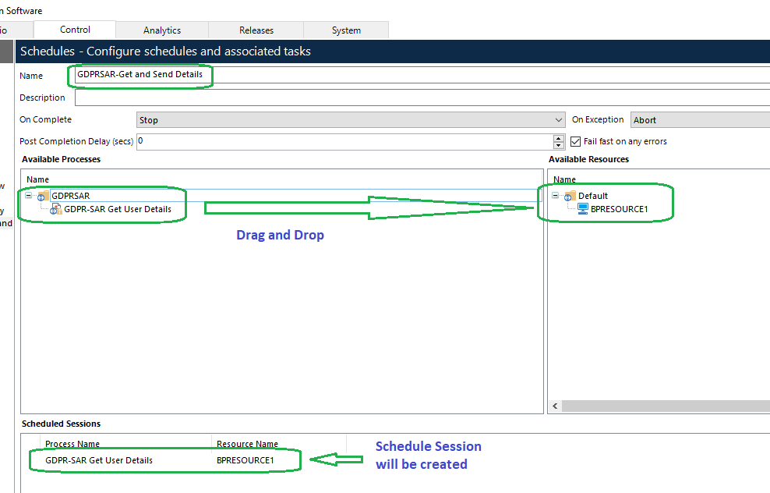

### Click on Apply Changes

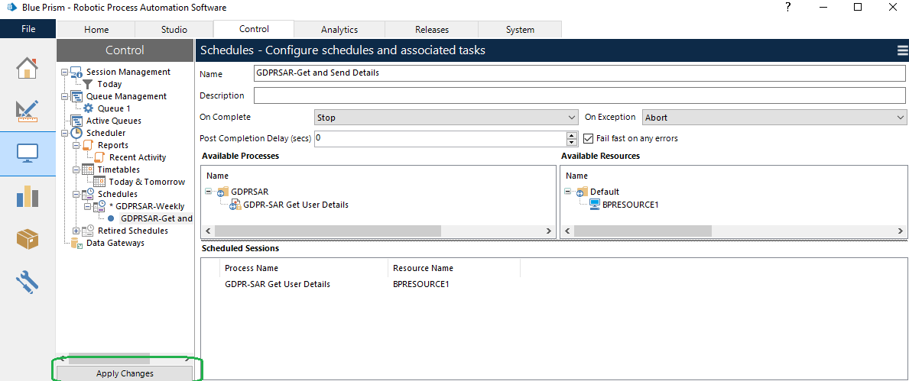

8.2.7 BOT will trigger as per scheduled time (make sure there is no other process scheduled or running on same resource on scheduled time else scheduler will discard the execution for the one which will trigger later)

# Document History

This section details the history of the document at each version. It’s good to know what has changed in each version, by who, and when it happened.

|  |  |  |  |
| --- | --- | --- | --- |
| **Version** | **Date** | **Changes** | **Author** |
| 1.0 | 07-Nov-2019 | Draft Version | Ram Niwas Verma |
| 2.0 | 24-Nov-2019 | Included execution steps | Ram Niwas Verma |